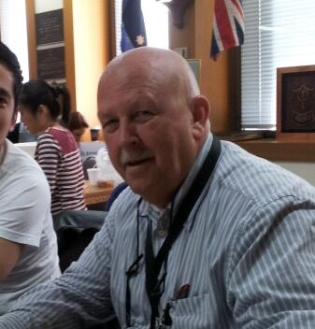
Show me the Value
As a new member of the PMI Board for 2013, I hope to bring a Governance and Assurance focus to our Critical Path Newsletters. And as all projects begin with benefits in mind, what better place to start 2013 than with some refresher material on Benefits Management – or better still, on Value Management.
By the time you read this article, Stephen Jenner will have completed his latest visit to Australia and New Zealand to deliver his Seminar Series on ‘Delivering Value via Project Portfolio Management”. As a world leader in Benefits Management, Steve advocates that maintaining a benefits focus, both during and after project completion, is the key to demonstrating value in project delivery. For those that missed Steve’s seminar, he has just released a new reference manual “Managing Benefits” (available through APMG) that will serve as a good backup of Steve’s seminar material.
Regular readers of The Critical Path may recall that it is just on 12 months since Craig Wilkins, Gareth Byatt, Gary Hamilton, and Jeff Hodgkinson’s great article on Benefits Realisation – the Unfortunate Truth featured in the March/April 2012 edition - this article is well worth revisiting.
Special mention should also go to an illuminating article by Jed Simms and Alex Chapman called “The Capital Crime” which highlights the issue of the diminishing benefits of projects that occurs through the failure to identify all of the benefits that relate to projects, and the failure to monitor project benefits once the project delivery phases have been completed. This article is a very good read and I strongly recommend that you read it, and see if you recognise any similarities with project benefit challenges in your organisation – then share it with your Project Stakeholders.
The challenges associated with identifying and measuring benefits – especially intangible benefits – quite often results in ‘something being left on the table’ that could reasonably have been included in the benefits identification and realisation for the project. If you think that measurement of intangibles is too hard, have a look at “How to Measure Anything” by Douglas W. Hubbard.
Chris McLoon
February 2013

